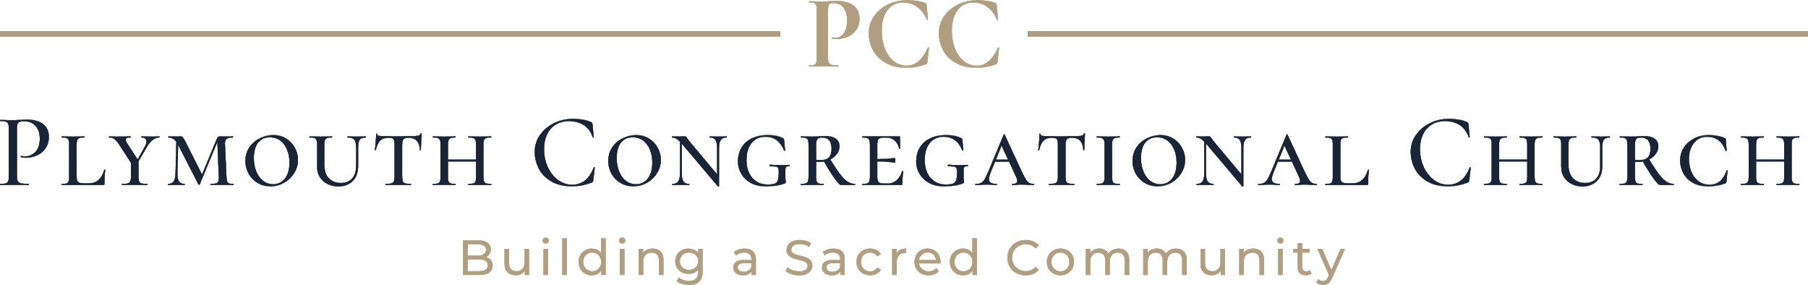

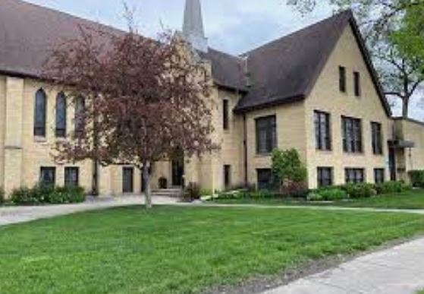

Do you know of someone in the community:

Plymouth Congregational is actively seeking a part-time, non-denominational Pastor/leader for our church.  If you know of someone in the community that would be interested, please have them contact us.

Plymouth Pastoral Search Committee

Plymouth Congregational Church

901 Broadway N

Fargo ND 58102

701-235-9226

Send your resume and letter of interest to:

Patty at [plymouthfargo2@gmail.com](mailto:plymouthfargo2@gmail.com)

Thank you for your time and have a blessed day!